**Introduction:**

We collect the data and make a research on it. I will show you what we make in this project.

**Problem Definition & Desing thinking:**

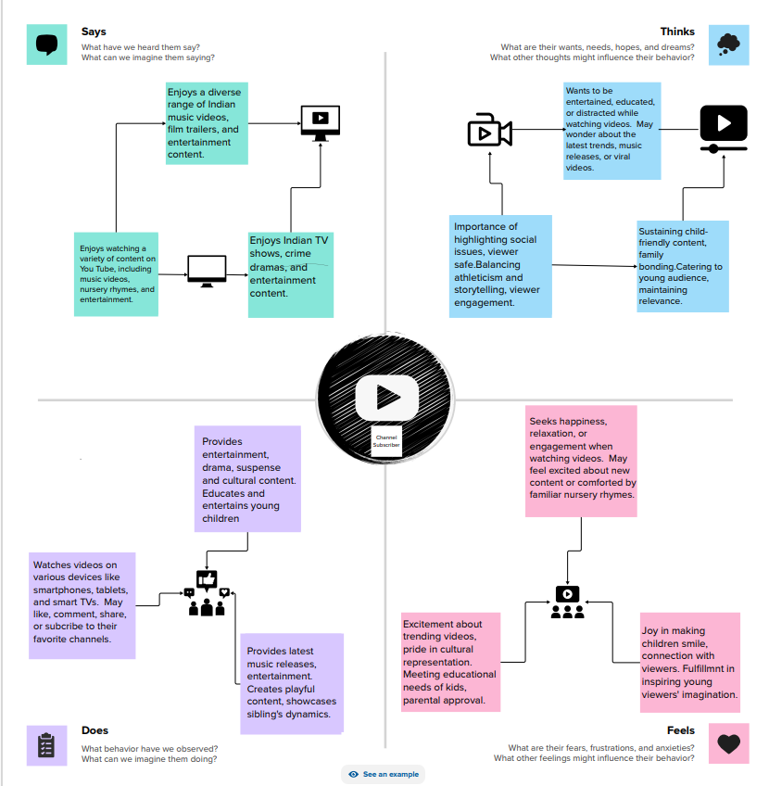

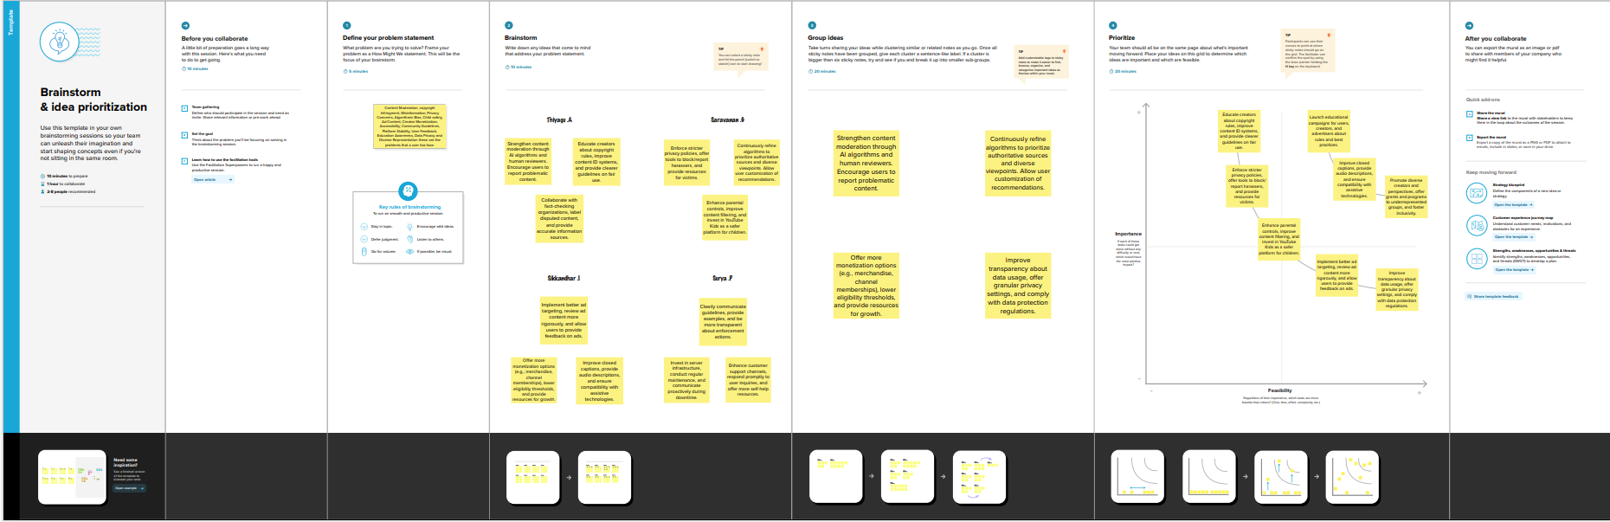

**Result:**

It gives us a oral brief view of the project. It can helpful to future reference.

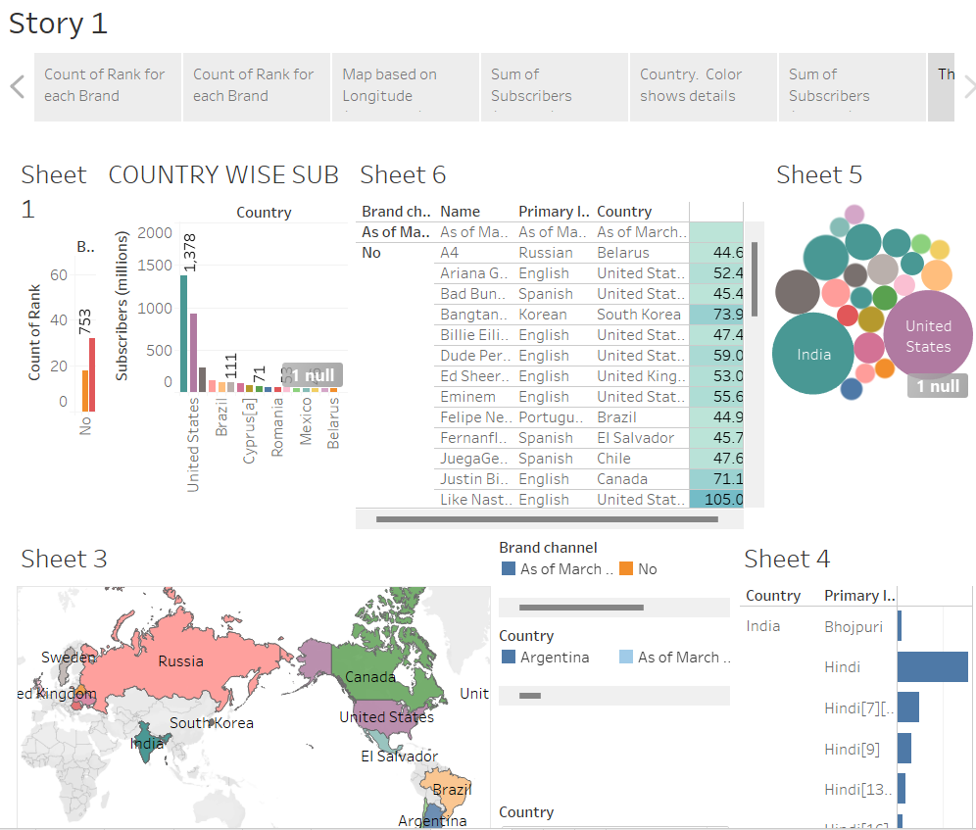

**Advantages & Disadvantages:**

It gives the data of present satiation and past view.

It can help full for predicting the people’s interest in the field.

It may be change in the future.

**Applications:**

It can use full for the big internet related companies

It make gives us peoples data.

**Conclusion:**

You tube is the most effective private free learning plate form.